**PROGRAM 2**

**Aim**

To write a Python program to solve the **N-Queens Problem** using the **Backtracking algorithm** and display all possible arrangements of N queens on an N×N chessboard such that no two queens attack each other.

**Algorithm**

1. Start with an empty chessboard of size N × N.
2. Place a queen in a row, column by column:
   * Check if the position is **safe** (no queen in the same column, and no queen on both diagonals).
   * If safe, place the queen.
3. Recursively place queens in the next row.
4. If all queens are placed, print the solution.
5. If placing a queen leads to no solution, backtrack (remove the queen) and try the next column.
6. Repeat until all solutions are found or conclude no solution exists.
7. Stop.

code

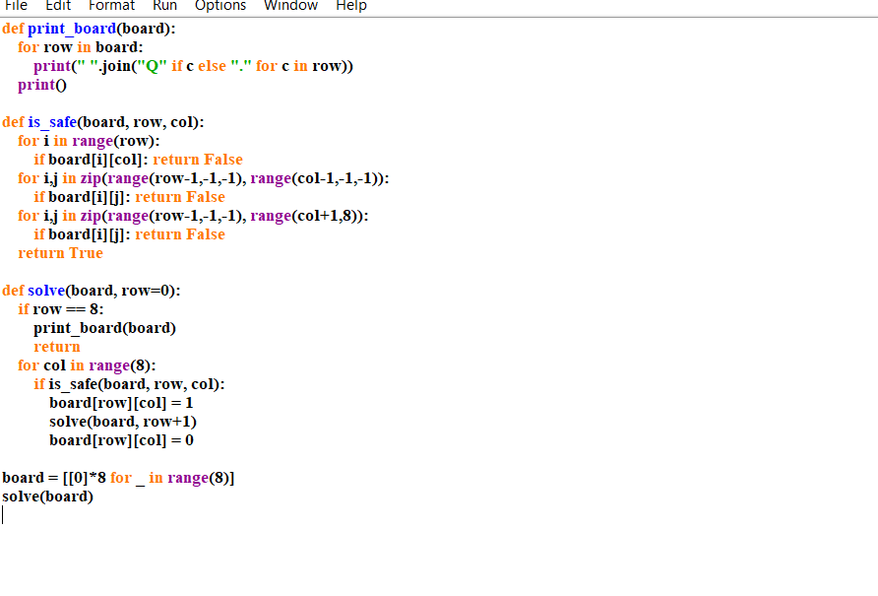

Output :

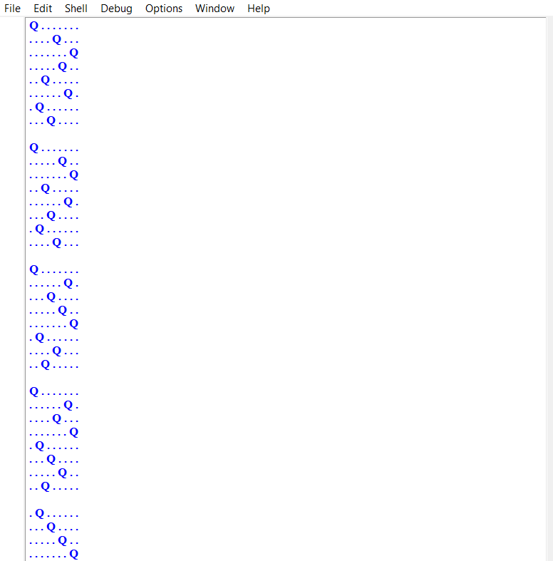

Result :

Thus, the N-Queens problem is successfully solved using the backtracking approach